|  | **FPT ACADEMY INTERNATIONAL**  **FPT – APTECH COMPUTER EDUCATION** |
| --- | --- |

**Centre Name: ACE-HCMC-2-FPT.**

**Address: 590 Cach Mang Thang 8, District 3, Ho Chi Minh City, Viet Nam.**

**[T2P Store]**

| **Supervisor:** | Phạm Thị Lánh | |
| --- | --- | --- |
| **Term:** | 1 | |
| **Batch No:** | T1.2206.M1 | |
| **Group No:** | 2 | |
| **Order:** | **Full name** | **Roll No.** |
| 1. | Đỗ Ngọc Cát Tường | Student1394612 |
| 2. | Lê Quang Huy | Student1352239 |
| 3. | Nguyễn Quốc Huy | Student1363366 |

Month 10 Year 2022

This is to certify that

**Ms. ĐỖ NGỌC CÁT TƯỜNG**

**Mr. LÊ QUANG HUY**

**Mr. NGUYỄN QUỐC HUY**

Have successfully Designed & Developed

**T2P Store**

Submitted by: **Mrs. PHAM THI LANH**

Date Of Issue: Octorber, 2022

Authorized Signature:

# Content

**Content** **3**

**Acknowledge** **5**

**Synopsis** **6**

**REVIEW 1** **7**

Problem Definition 8

Customer Requirements Specifications 9

Architecture and Design of the project 10

Site map 11

Screenshots 12

Homepage 12

Sign In 14

Sign Up 15

Product Category/Search Page 15

Product Comparison 18

Product Detail 19

Cart Dropdown 20

Check out 21

Contact 22

About 23

List News 24

News Page 25

Policy Page 25

Task Sheet 28

**REVIEW 2 29**

# 

# Acknowledge

As we understand that the eProject is a step-by-step learning environment that closely simulates the classroom and Lab based learning environment into actual implementation. It is a project implementation at your fingertips!! An electronic, live juncture on the machine that allows you to.

✓ Practice step by step i.e., laddered approach.

✓ Build a larger, more robust web design and development.

✓ Usage of certain utilities on the web designed by the user.

✓ Single program to unified code leading to a complete website.

✓ Learn the implementation of concepts in a phased manner.

✓ Enhance skills and add value.

✓ Work on real-life projects.

✓ Give a real-life scenario and help to design and development web more complicated and useful.

✓ Mentoring through email support.

We would like to send a great thanks to our professor and other students for their adorable support during the time in the project.

Besides several mistakes we made in the project, we hope to have more opportunities to widen our knowledge in the web developing world.

We also thank you so much for your information and the “demo” project from India APTECH to help us get a more realistic experience in this project. Since we have gained more experience from this project, we will not stop learning anything as much as we can to be more successful in the future.

Your Sincerely, Team Group 02.

# 

# Synopsis

- The Objective of this program we aim is to give a sample project to work on real-life projects. These applications help us build a larger, more robust web design and development.

- The objective is not only to help us understand more HTML/CSS/JavaScript/AngularJS/JQUERY but also to provide us with a real-life scenario and help us create basic applications using the tools.

# 

# 

# 

# 

# 

# REVIEW 1

## Problem Definition

# Wireless World has years of experience in the international consumer electronics market.

# We have a structured, dynamic, competitive work team, committed to their work and with a great sense of belonging. We permanently innovate in our processes and technology services portfolio in the face of challenging market changes. We constantly bet on new projects to renew our offer and add value to our customers, innovating in products, services, knowledge transfers, and growth. We help our customers obtain the most innovative electronic products, from top brands at competitive prices. We currently have a large inventory with more than 40 leading brands in the consumer electronics and computer industry.

# Understanding that markets change and customers evolve. We help them find comfort when making a purchase.

# We work with products from Samsung, Apple, Nokia, LG, Motorola, Alcatel, CAT, Sony, HTC, Blackberry, Huawei, ZTE, and Xiaomi, among others.

# You are supposed to create a Single-Page-Application and responsive Website for them with the below-mentioned requirement specifications. The website is to be developed for the Windows Platform using HTML5, JSON, Angular JS, JavaScript, and Geolocation. The site should work well in all leading browsers including Chrome, IE, Firefox, etc.

## Customer Requirements Specifications

# The portal will be designed as a Single-Page-Application and responsive Website with

# a set of pages and menus that represent choice of activities to be performed. The

# pages, menus, and other visual elements must be designed in a visually appealing

# manner with attractive fonts, colors, and animations. All of these should also be laid

# out in a responsive manner.

# Depending on the decision given by the management on the Web site to be created

# following are the requirements based on which the website needs to be developed.

# The Web Page should be created with proper sections, graphics, and logo.

# A Menu should be created which would categorize all the information about the features provided on the Site For e.g. a Menu for Various Cell phones, a Menu for Features of Cell phones, etc.

# Page should have sections like TOP Selling Mobile Phone, Best Budget smartphone (Under $200), Best Offers on Mobile.

# The information should be categorized according to the Brand names of Mobiles like if a User wants to see only Samsung Phones then move to Samsung section and similarly for Top 5 Brands. Rest other brand phones should be listed under All Mobile Phones section.

# The features of Individual phones should be displayed on the Web Page along with the Cell phone images.

# User should be able to select maximum three mobile devices to compare. Comparison section should also be there where there is Phone comparisons done with various models of same brand or various models of various brands.

# The Comparison information should be provided in Tabular format comparing the features of different phones.

# The Colour Schemes should be soothing, more of Pastel Colours can be chosen for the same.

# When a particular brand phones are being displayed the background image of the Web page should show the Logo of that brand for e.g. if Samsung Phones are being displayed then that page should have the Logo of SAMSUNG as the background image and the same in case of other Brands.

# About Us, Site map, Gallery, Contact us link must be added.

# There would be two types of users: registered and non-registered users.

# Registered Users should be able to add products to cart.

# Non-Registered users should only view the products on the site.

Over and above this, the portal should implement the following functionalities:

* Display a continuous scrolling ticker at the bottom of the page with current date,
* time, and location (hint: Use geolocation features of HTML5).
* Display a visitor count at the top right corner of the page beside a logo image.
* The menu options should change color on hover and also after clicking.
* Fade in and fade out options can be used for the menus.

# 

## Architecture and Design of the project

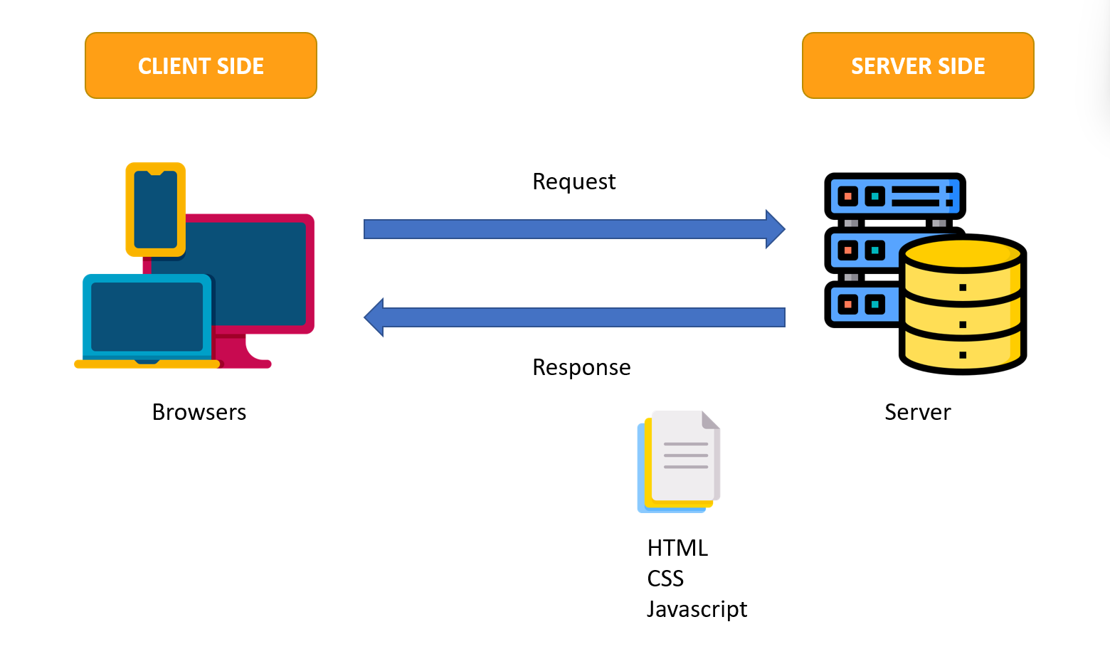

## Site map

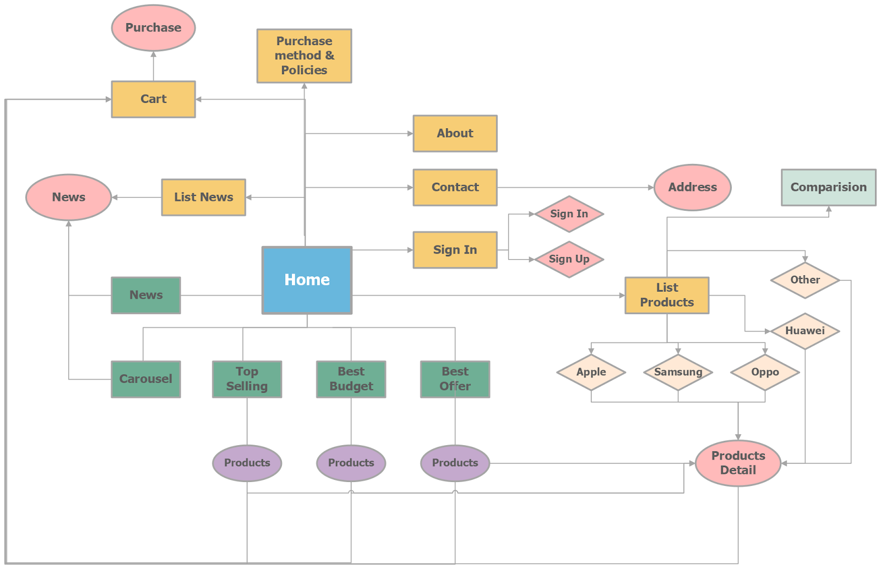

## Screenshots

1. **Homepage**

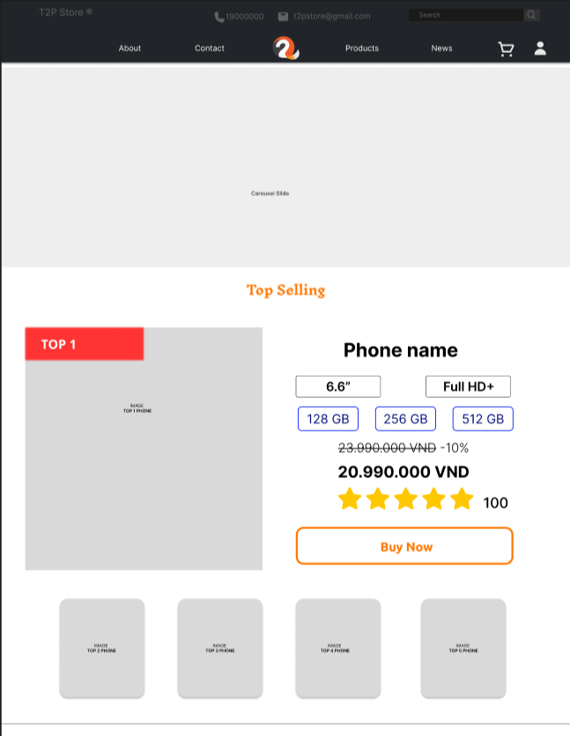

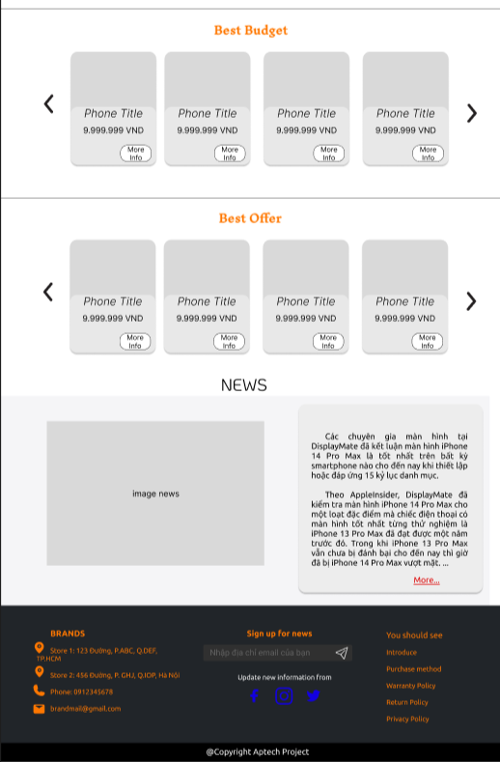

**Description:** This is a homepage of T2P Store, the top of this page is a header after that is a navigation bar. The main part of the homepage beside the slider also includes 3 sections: hot seller, best sellers, best budget, and news. The footer has links to subscribes, information pages, purchase methods, policies, and contact information.

1. **Sign In**

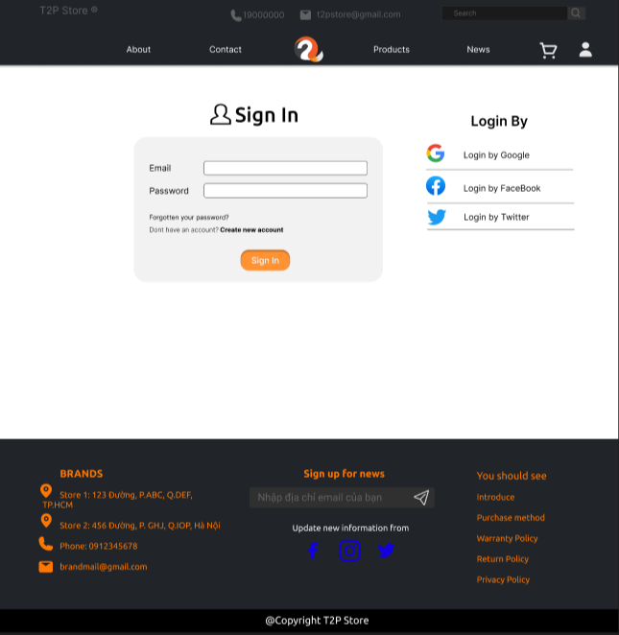

**Description:** When the user clicks on the human icon in the header, it leads to a sign-in page. This form requires the user to enter an email address and a password. After clicking the Sign In button, the user will be redirected to the homepage.

1. **Sign Up**

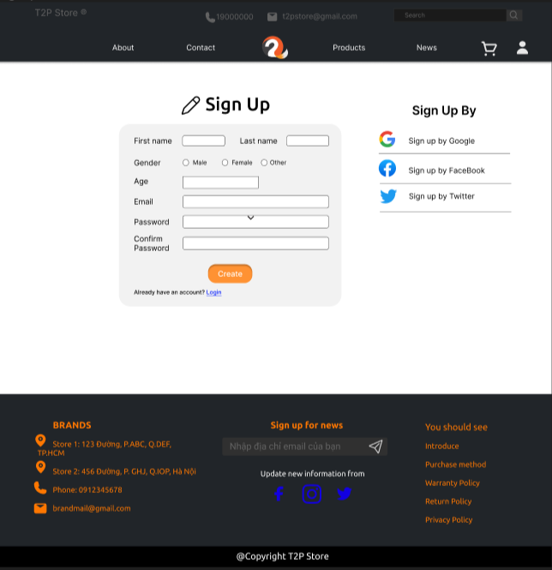

**Description:** If the user hasn’t created an account, they can click to “Create new account” in the **Sign-in** page and it will lead to this **Sign-up** page. This sign-up form requires the user to enter 4 fields: first name, last name, gender, Age, email, password and confirm password. After clicking the Create button the user will be redirected to the homepage.

### Product Category/Search Page

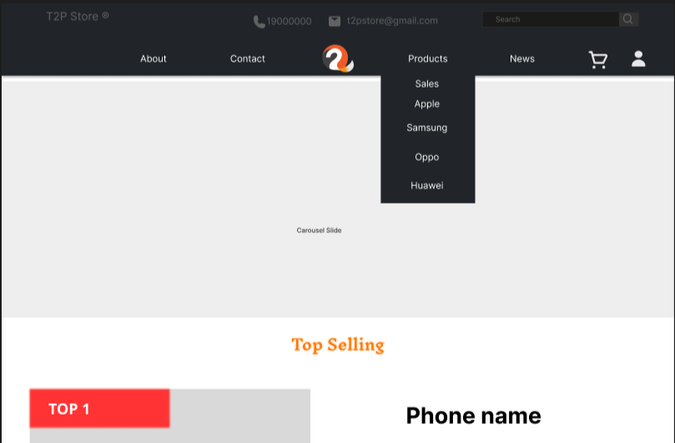

**Description:** When users mouse into Products in the navigation bar, it will show up a list that contains links to get into sales items and brand products. Or the user can click on Products to get a list of all items the store has. After users click on any brand name or sales or products to list cell phones, The user will get to the list page which will describe below.

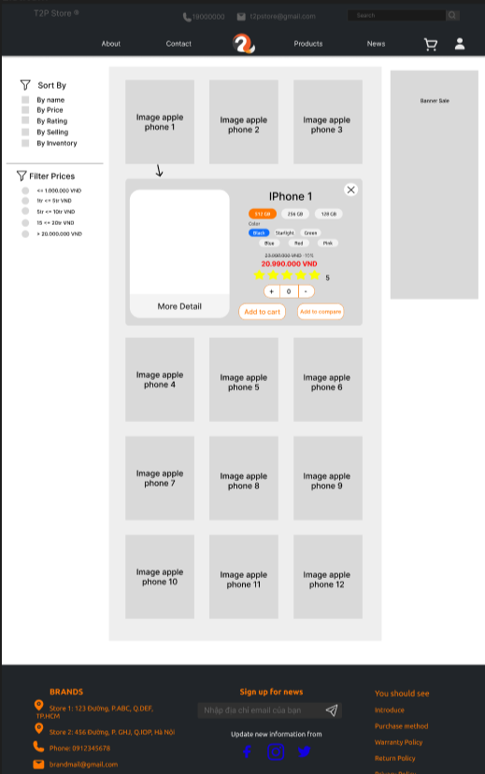

**Description:** A list of cell phones about the brand user choose or sales products that the store has will show up. On the right side, we have many selectors for users to filter cell phones by brand, or order by name, price, rating, ….. When the user chooses any cell phone, a small description of that cell phone will show up below it.

### Product Comparison

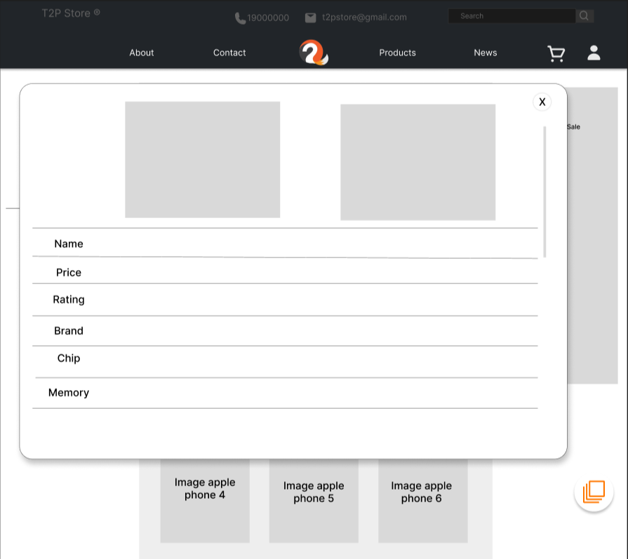

**Description:** If users want to compare 2 items, they can click on Add to compare, and after one item was be clicked, a circle will appear in the bottom right of the site, then after the user choose another item that they want to compare, they can click on the circle, a pop-up will show, it will show 2 cell phone detail.

### Product Detail

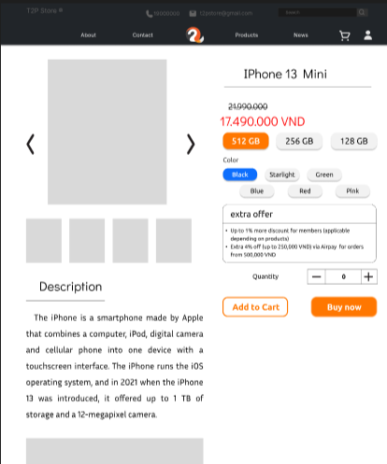

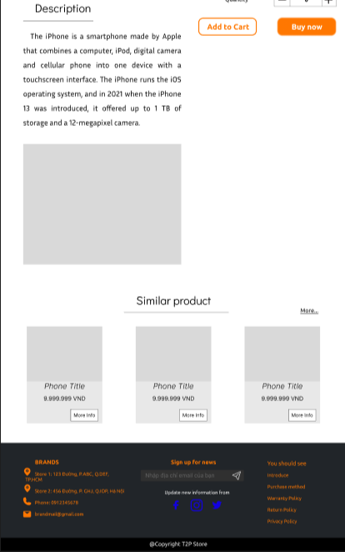

**Description:** In the list of cell phones, users can mouse into the picture of the selected cell phone, and there is a small div showing up with content in more detail. After clicking on the picture of the cell phone, redirect to the Product detail page, in there, users can see more detail describing that cell phone, which also shows up what type and color of the phone that user wants to buy. After choosing, the user can choose “Add to cart” or “Buy now” to get it into the cart or redirect to the Checkout page. Below the cell phone detail, the page shows users more related phones.

### Cart Dropdown

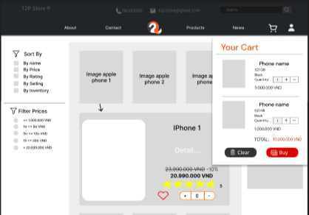

**Description:** When the user clicks on the cart icon in the header, the cart information will appear. It includes products that users have already added to the cart, the user can select all items or remove items that they don’t have the intention to buy.

### Check out

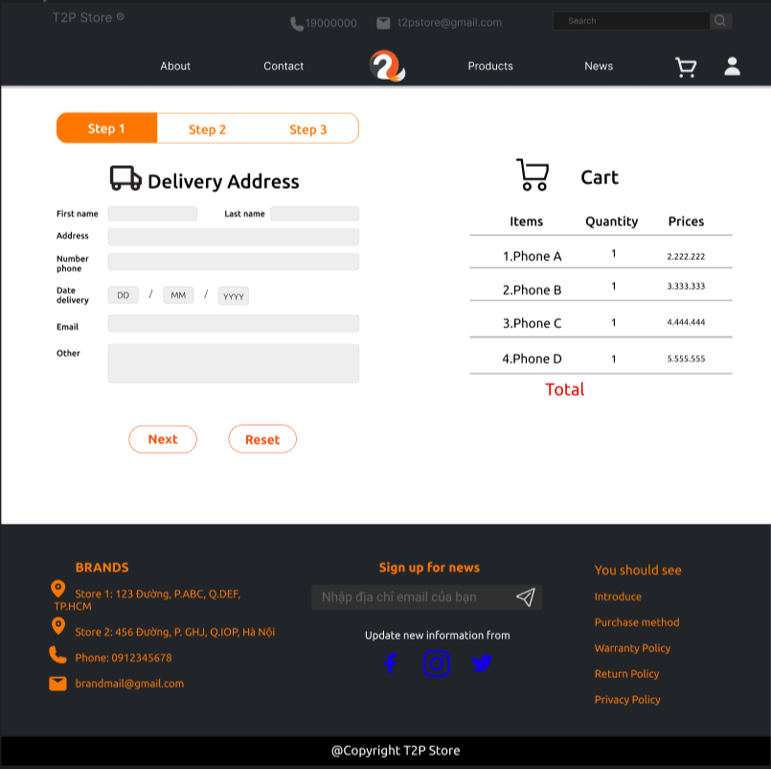

**Description:** After clicking the Check out button on the Cart or Buy now button on the Product Detail Page, the user will be redirected to this checkout page. The left part of this page contains a form that requires the user to enter and the other side is the Order summary.

Step 1: Users finish the form about information of users and delivery information.

Step 2: Users choose a payment method.

Step 3: Finish payment. It will show up all information about delivery that the user input and all items the user choose.

### Contact

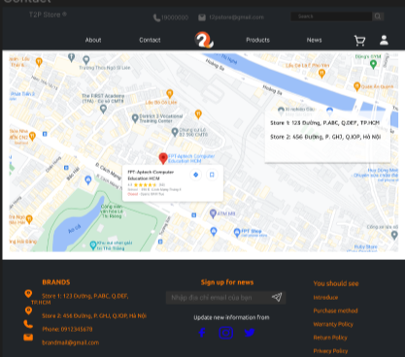

**Description:** After clicking the Contact tag on the navigation bar, the user will be redirected to this page. The main part of this page is a map, beside it is a detailed location of Bright World’s Branches.

### About

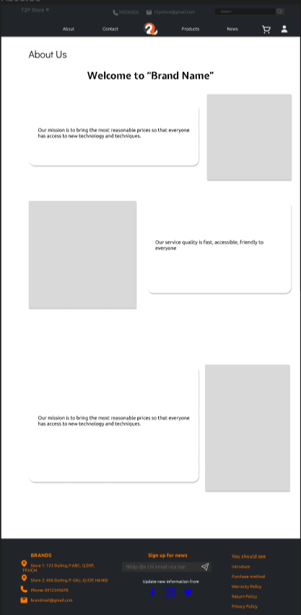

**Description:** After the user clicks on the About tag on the navigation bar, it will lead to this about page. This page contains detailed information about Bright World.

1. **List News**

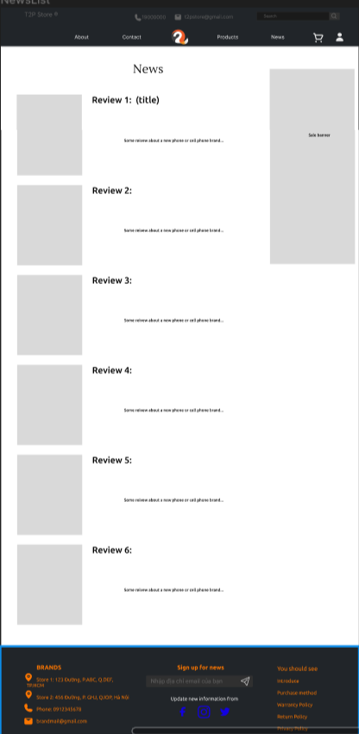

**Description:** After the user clicks on the News tag on the navigation bar, it will lead to the List news page. This page contains some news about the new cell phone or reviews about any cell phone.

1. **News Page**

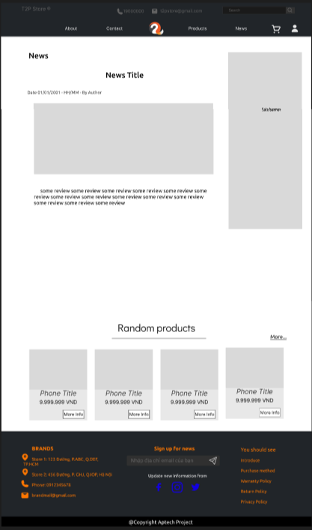

**Description:** After the user clicks on any News in the list news it will lead to the news page. This page contains content about that news.

1. **Policy page**

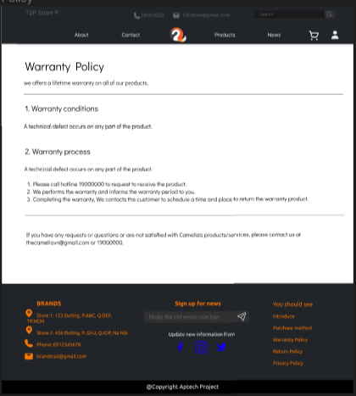

**Description:** After the user clicks on any Policy in the footer or Payment method. The Policy page will show up, and which each policy, the content will be different.

## Task Sheet

| **Project Ref No.** | **Project Title** | **Activity Plan Prepared by** | **Date of preparation of Activity Plan** | | | |
| --- | --- | --- | --- | --- | --- | --- |
| **Task** | **Actual Start Date** | **Actual Days** | **Teammate Names** | **Status** |
| Brainstorming ideas for layouts and Project Object | | Tường  Quang Huy  Quốc Huy | 01/10/2022 | 1 days | Tường  Quang Huy  Quốc Huy | Completed |
| Draw site maps, and architecture design | | Tường  Quang Huy  Quốc Huy | 02/10/2022 | 1 days | Tường  Quang Huy  Quốc Huy | Completed |
| Wire framing general page layout | | Tường  Quang Huy  Quốc Huy | 04/10/2022 | 3 days | Tường  Quang Huy  Quốc Huy | Completed |

**REVIEW 2**

